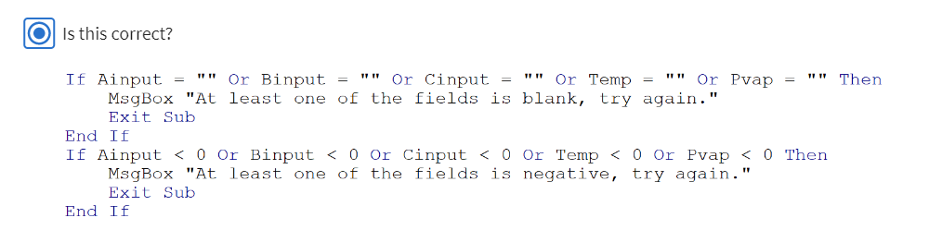





**0.6**



**0.6**



**0.6**





**0.6**



**0.6**

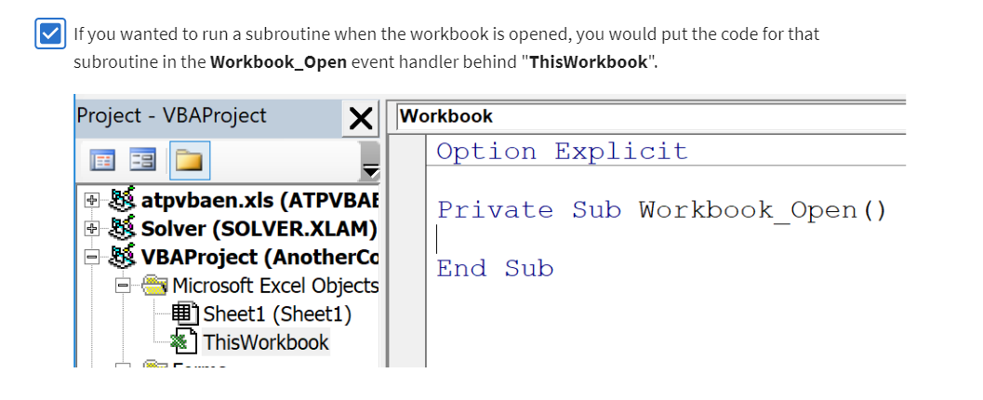

**0.6**

6



